The British Isles

Name ___________________________ Date ___________________
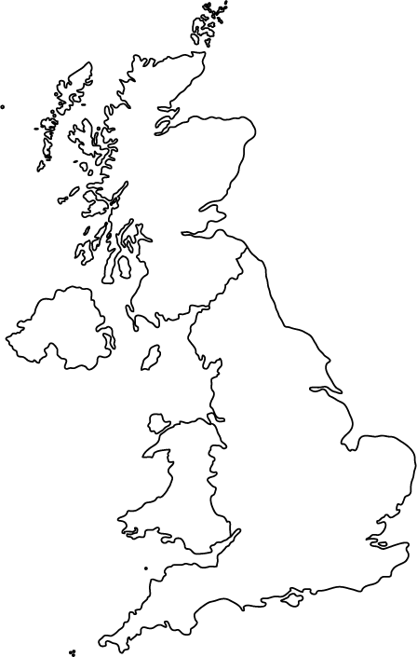

Label the following places on the map of the British Isles above: The Isle of Man, Scotland, Ireland, England, Wales. Color each a different color.

